Jira Automation: Save Time without Admin Rights

1. What Can Be Automated in Jira by Non-Admins?
Jira allows non-admin users to create project-level automation rules that help reduce manual work and improve consistency.
Automation Scope for Non-Admins
Non-admins can automate within their project, but not global Jira settings.

What Non-Admins CAN Automate
✔ Auto-assign issues
✔ Auto-transition issues
✔ Auto-add labels
✔ Auto-update fields
✔ Auto-add comments
✔ Notify teams on changes
✔ Trigger actions on status change

What Non-Admins CANNOT Automate
✖ Modify workflows
✖ Create global automation rules
✖ Change permissions
✖ Create new issue types

Hands-On Lab 1: Open Automation
- Go to your Project
- Click Project Settings
- Select Automation
- Click Create rule
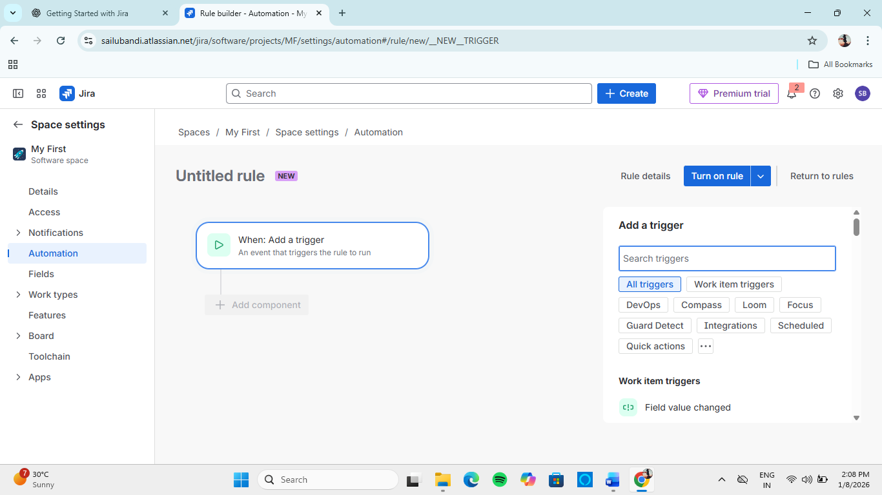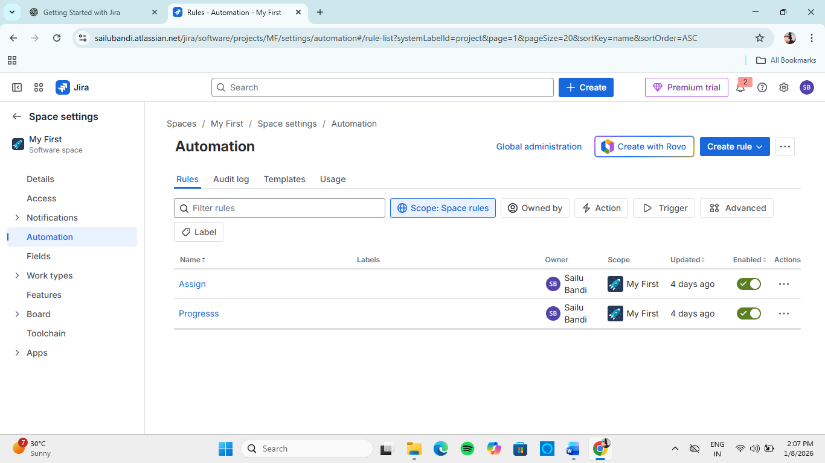

2. Smart Checklists: Creating Reusable Checklists in Jira Issues
Jira does not have built-in checklists by default, but smart checklists can be created using issue descriptions, subtasks, or templates.

2.1 Checklist Using Description (Simple & Effective)
Example Checklist Template
☐ Requirement analysis completed
☐ UI design approved
☐ Backend implemented
☐ Testing completed
☐ Code reviewed

Hands-On Lab 2: Use Checklist in Issue
- Create a new issue
- Paste checklist into Description
- Tick items during progress updates
- Update checklist regularly
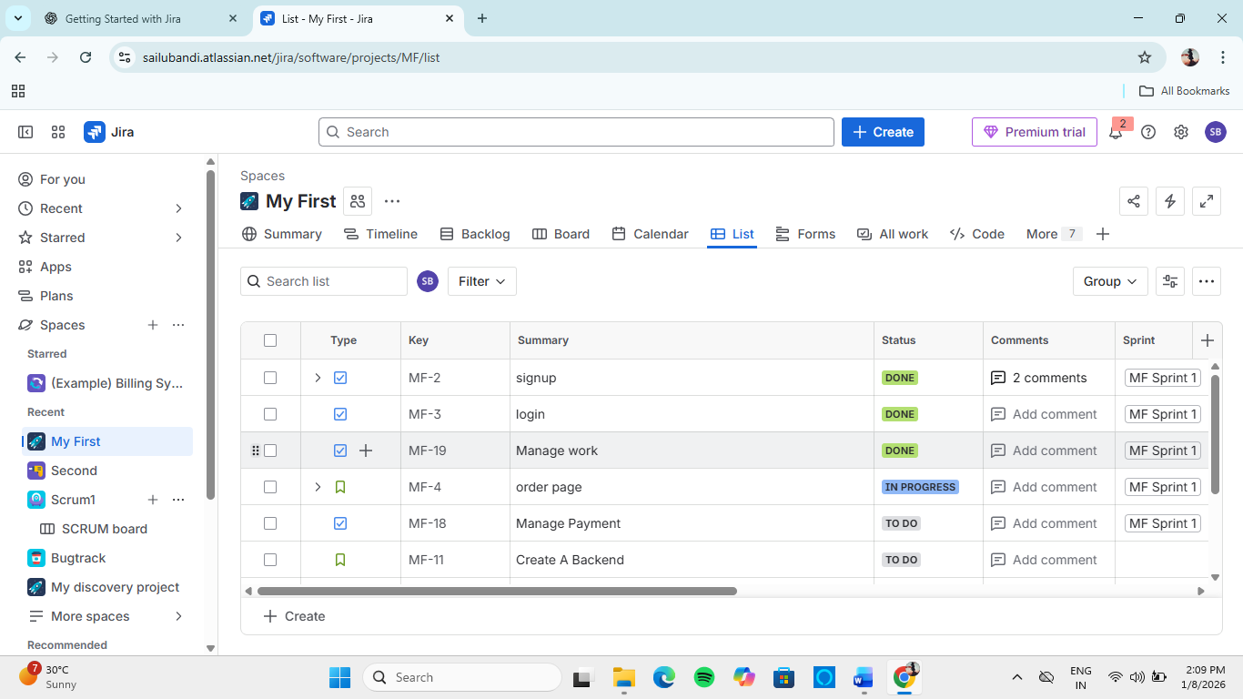

2.2 Checklist Using Subtasks (Recommended)
Each checklist item becomes a subtask.
Advantages
✔ Better tracking
✔ Clear ownership
✔ Progress visibility

Hands-On Lab 3: Create Subtask Checklist
- Open a parent issue
- Click Create subtask
- Add steps like:
  - Design
  - Development
  - Testing
- Track completion individually
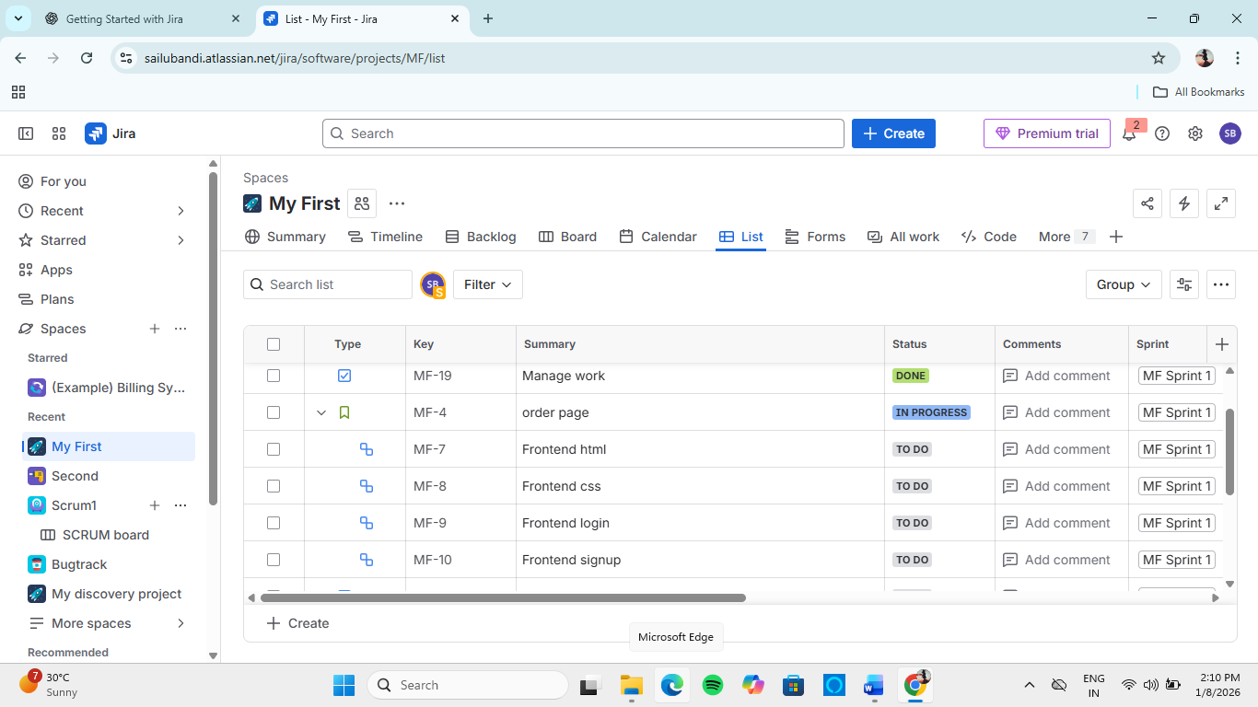

3. Examples of Simple Automation Rules for Teams
3.1 Auto-Assign Issues
Use Case:
Automatically assign bugs to QA lead.
Rule Logic
- Trigger: Issue Created
- Condition: Issue Type = Bug
- Action: Assign issue to QA lead

Hands-On Lab 4: Auto-Assign Rule
- Create rule
- Select Trigger → Issue Created
- Add Condition → Issue Type = Bug
- Add Action → Assign issue
- Save & enable rule
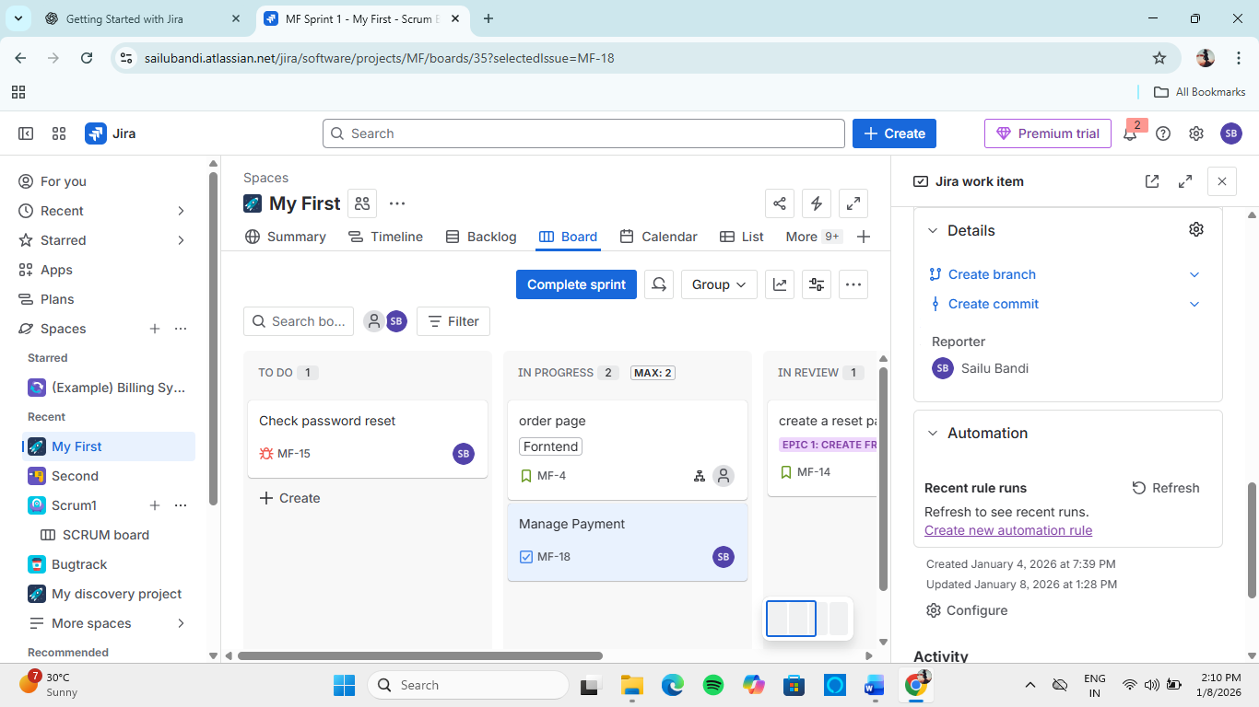

3.2 Auto-Transition on Completion
Use Case:
Move issue to Done when all subtasks are completed.
Rule Logic
- Trigger: Subtask transitioned
- Condition: All subtasks done
- Action: Transition parent issue

3.3 Auto-Add Labels
Use Case:
Add urgent label to high-priority issues.
JQL Condition
priority = High
Action: Add label urgent

3.4 Auto-Comment for Status Change
Use Case:
Notify team when issue is blocked.
Comment Example
⚠️ Issue blocked. Please review dependencies.

4. When to Ask Admins for Help with Jira Automation
Some automation requirements must involve Jira administrators.

Ask Admins When You Need To
✔ Automate across multiple projects
✔ Modify workflows or transitions
✔ Create global rules
✔ Use advanced conditions or scripts
✔ Integrate external tools

How to Communicate with Admins (Professional Way)
“We need a global automation rule to transition issues across multiple projects when deployments are completed.”

5. Best Practices for Jira Automation
✔ Keep rules simple and readable
✔ Name rules clearly
✔ Test rules before enabling
✔ Avoid conflicting rules
✔ Document automation purpose

6. Learning Outcomes
After completing this module, the learner can:
- Identify automation possibilities without admin rights
- Create simple automation rules
- Use smart checklists for consistency
- Know when to involve Jira administrators

